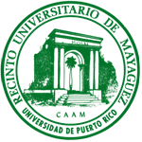
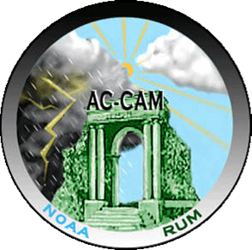


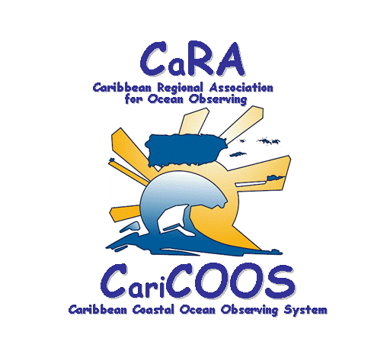

NOAA CENTER FOR ATMOSPHERIC SCIENCES (NCAS) WEATHER CAMP APPLICATION FORM
July 27 – August 1, 2009 – University of Puerto Rico at Mayagüez
Only U.S. Citizens or Permanent Residents may apply.
Please read information carefully and type or print clearly in blue or black ink.
PERSONAL DATA
Name

[Last] [First] [Middle Initial]
Current Address

Social Security Number |  | Date of Birth
Home Phone Number | Cell Phone Number | Personal E-mail Address
Name of Parent/Guardian |  | Parent/Guardian Address (if different from Current Address)
Parent/Guardian Work Phone Number |  | Parent/Guardian E-mail Address
ACADEMIC STATUS: Junior ___ Senior ___ HS Expected graduation date:__________
High School (Name & Mailing Address)
School Phone Number |  | School Fax Number
Overall Cumulative GPA/scale (ex. 3.50/4.00) |  | On a separate page, please list Advanced Placement Honors or college classes taken, if applicable. Please list any high school honors, activities, team memberships, awards received and/or jobs held.
Are you interested in pursuing a degree in meteorology, atmospheric sciences or oceanography? Yes_____ No_____
Guidance Counselor

_______________________________________________ __________________________________________________
Signature Printed Name

Counselor’s Telephone Number |  | Counselor’s E-mail Address
Career Interests (use an additional page if necessary) |  | How did you learn about Puerto Rico Weather Camp? (School, science fair, organization (name), family, friend, flyer, etc.)
I have read and understand the description and eligibility criteria for the University of Puerto Rico, NOAA Center for Atmospheric Sciences Weather Camp. I give the University of Puerto Rico permission to review my child’s complete academic record for consideration.

Parent or Guardian’s Signature:

Printed Name:

Date:

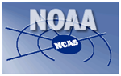

NOAA CENTER FOR ATMOSPHERIC SCIENCES (NCAS)
University of Puerto Rico at Mayagüez
Puerto Rico Weather Camp 2009 Application Checklist

Please provide all the items listed below for the application process. Only completed packets will be reviewed by the NCAS office.

Application


Please submit a cohesive typewritten personal statement (one page, single spaced, and 12 point – Times New Roman font) which addresses the following questions:
• Why are you interested in weather?
• What do you hope to learn from the weather camp?
• Why should you be accepted into the weather camp?
(Also add anything that may be helpful or beneficial to know about you)

One letter of Recommendation (can be from your science teacher). (These should be provided by non-family members and are to be enclosed with the application)

* Remember to fill out the application form in its entirety.

* Print clearly or type your information on the application form.

* Considerable weight will be given to the letter of recommendations and the personal statement, so please include them with the application.

Completed application packages must be received no later than Friday, April 3, 2009 at 5:00 pm

Return application packet by mail to the following address:

Dr. Yasmín Detrés
NOAA Center for Atmospheric Sciences (NCAS)
Department of Marine Sciences
University of Puerto Rico
PO Box 9013
Mayagüez, P. R. 00681

E-mail: yasmin.detres@upr.edu

Phone: 787-899-2048 Ext 283 Fax: 787-899-2630

Application materials are also available on:
http://bio-optics.uprm.edu
http://ncas.howard.edu (outreach/weather camp)
THERE IS NO PARTICIPANT FEE FOR THIS PROGRAM

