
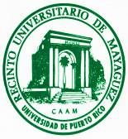
Our Star the Sun Center for Educational Excellence (OSSCEE)
University of Puerto Rico – Mayagüez, Puerto Rico

2010 NASA’S OSSCEE WORKSHOP
Remote Sensing: Educational Tool to Understand Land and Marine Processes
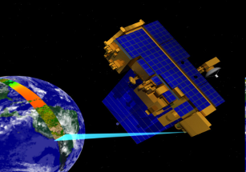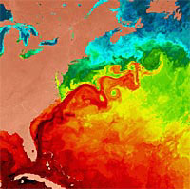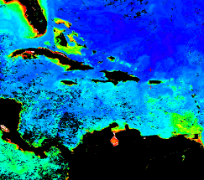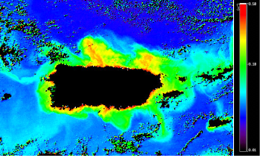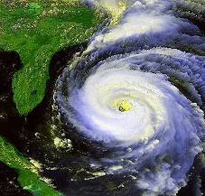

Application (Please print)

Name: __________________________________________________________

School: _________________________________________________________

School Address:___________________________________________________

School District (if applicable): _______________________________________

Home Address: ___________________________________________________

City: ____________________ State: _______________ Zip: _______________

Home Phone: _____________________________________________________

Cell Phone: _______________________________________________________

Email Address:_______________________________________________

Specific science areas that you teach: _________________________________________________________________
__________________________________________________________________________________________________________________________________

Indicate why you wish to take this workshop: ______________________
_________________________________________________________________
_________________________________________________________________
_________________________________________________________________

Write a short essay (300 words or less) indicating how your participation in the workshop will provide you with the necessary tools to reach effectively your students thus driving you to the achievement of educational excellence.

Please, complete and send to Ms. Jesennia Carrero (jcarrero.uprm@gmail.com) before May 7, 2010.

